

SECV3263 (SECTION 01)
MULTIMEDIA WEB PROGRAMMING

GROUP ASSIGNMENT:
Interactive 3D Tour of UTM Sports Hall 2

SUBMISSION DATE: 19TH JUNE 2026

LECTURER NAME :
Dr. Pang Yee Yong
KRISTINE ELLE BENJAMIN | A23CS0090
UTHAYA DARSHNI A/P PRAKASH | A23CS5047
ABBENISHA ANN MICHAEL BENEDICT | A23CS0029
NUR AIFA INSYIRAH BINTI HAIRUL AZMI | A23CS8005

1. Introduction
This project presents an interactive 3D campus tour of Universiti Teknologi Malaysia (UTM), specifically focusing on Sports Hall 2. The application allows users to explore the exterior parking area, the entrance lobby, and the indoor sports court within a web browser. The environment is rendered in real-time, providing an immersive experience complete with interactivity, navigational controls, and dynamic day/night lighting.

1.1 Project Background

Aaaa nantila

no nanti nanti

1.2 Project Overview

1.3 Project Objectives

2. Location Study

2.1 Introduction to Sports Hall 2

2.2 Reason for Selecting the Location

2.3 Location Facilities and Features

2.4 Target Users

2.5 Purpose of the Virtual Tour

3. Photo Documentation

3.1 Reference Photo 1
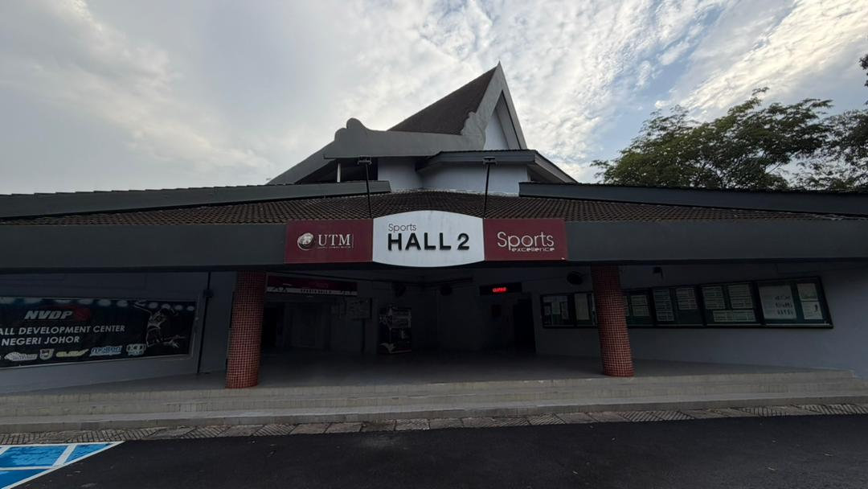

3.2 Reference Photo 2
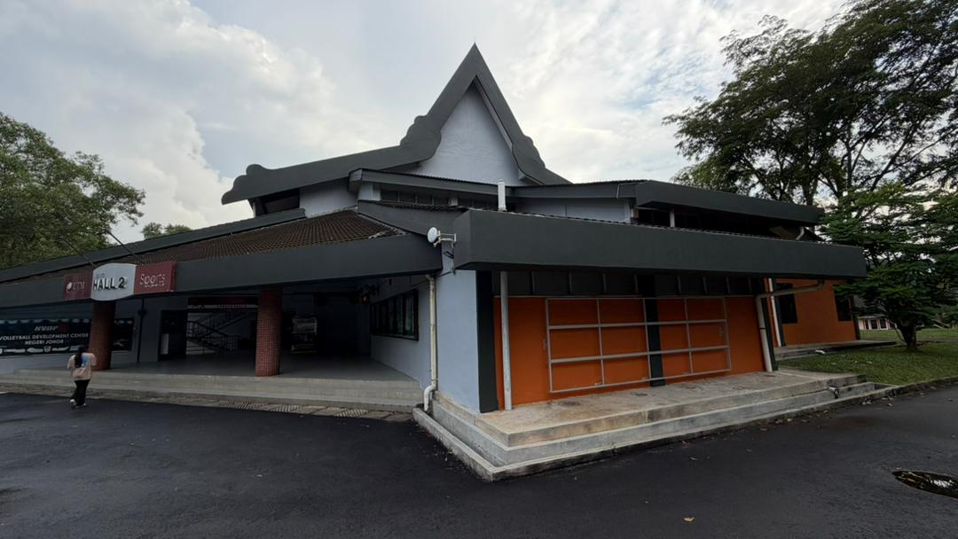

3.3 Reference Photo 3
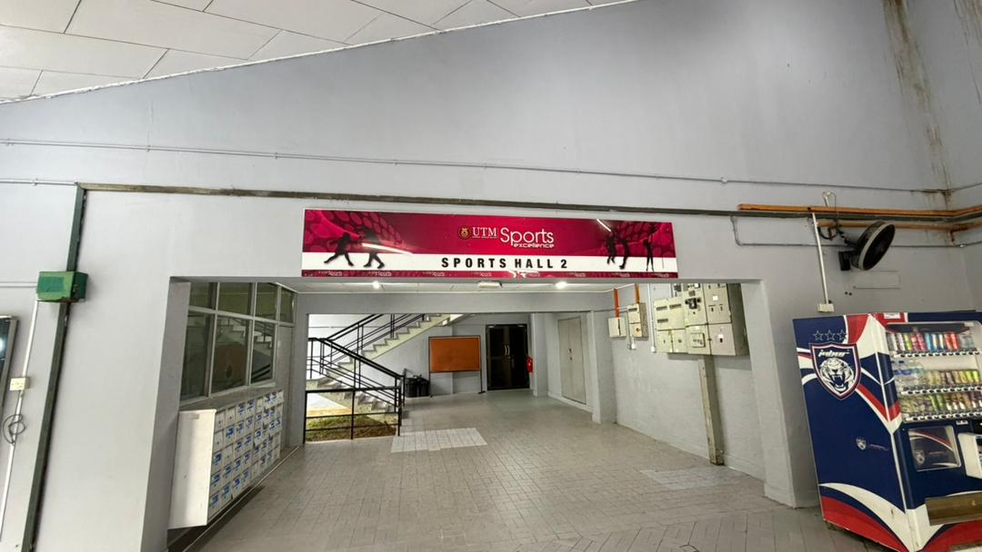

3.4 Reference Photo 4
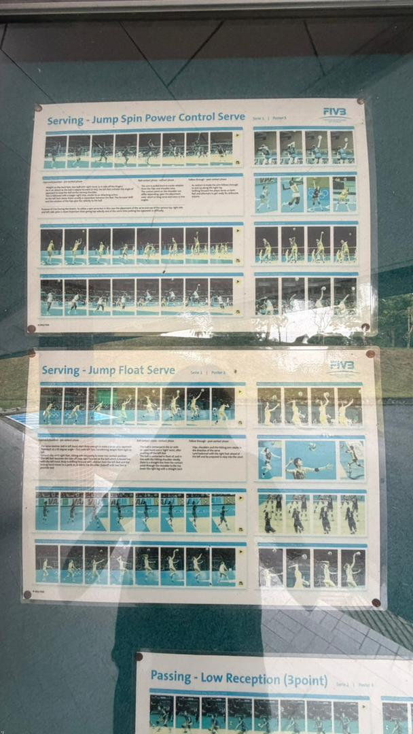

3.5 Reference Photo 5

3.6 Summary of Design References

4. Design Plan

4.1 Environment Layout Plan

4.2 Object Design Plan

4.3 User Interface Design

4.4 Storyboard

4.5 Tour Route Planning

5. System Development

5.1 Software and Tools Used

5.2 3D Modelling Process

5.3 Three.js Scene Development

5.4 Environment Construction

5.5 Navigation Implementation

6. Multimedia and Interaction

6.1 Interactive Features Overview

6.2 Information Hotspots

6.3 Object Highlighting

6.4 Day and Night Lighting Toggle

6.5 User Flow

7. System Interface

7.1 Welcome Screen

7.2 Navigation Guide

7.3 Information Panel

7.4 Main Tour Interface

8. Individual Contribution

8.1 Contribution Table

9. Conclusion

9.1 Project Achievements

9.2 Challenges Faced

9.3 Future Improvements

Appendices

